Configure VPC peering in cross regions

Creating a vpc peering for different regions

I have created 2 vpc in two different regions
- virginia and hyderabad
I have sent peering requesting from n.virginia to hyderabad region

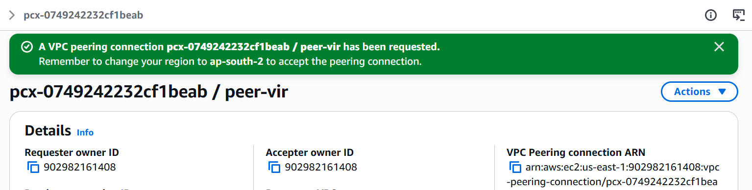

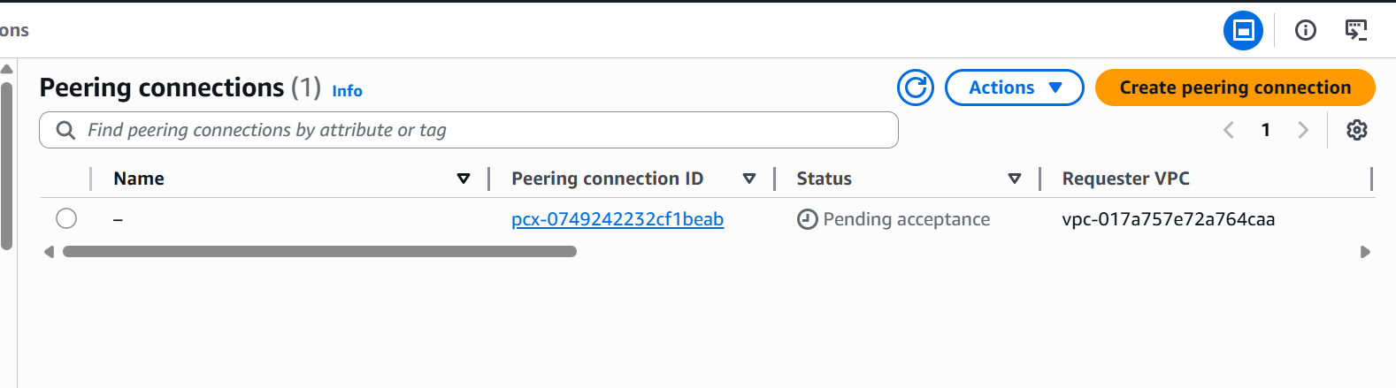
I have accepted the peering request in hyd region peering request

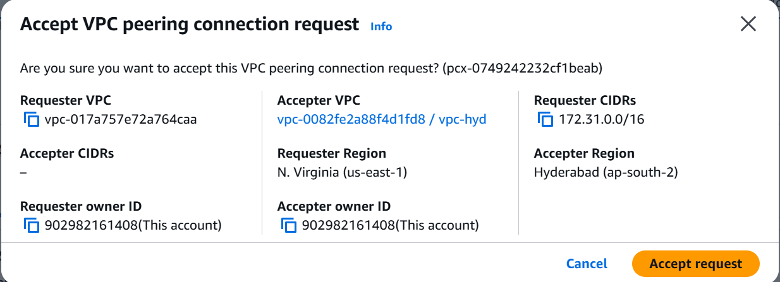

We can see now the peering connection is active blw two vpc from different region
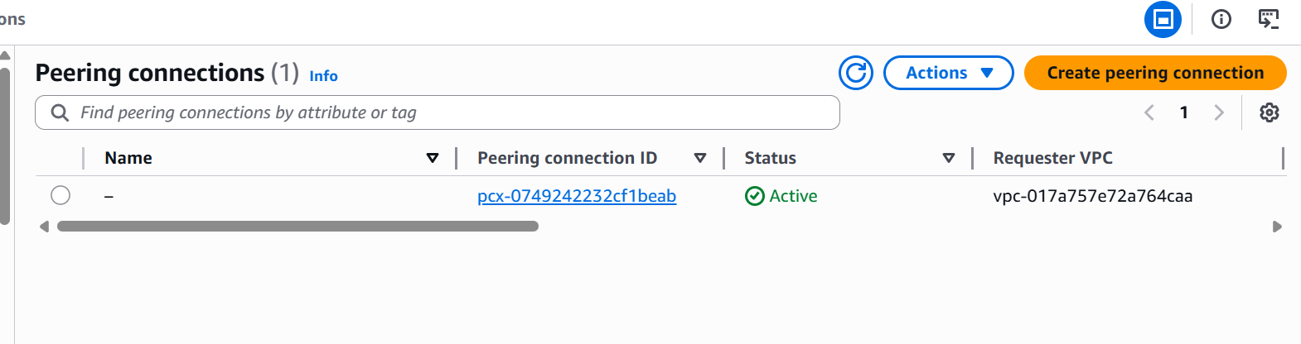

Purchase one domain from GoDaddy

I will be purchasing a new domian name from godaddy for my static website deployment

This will help us easily to remember the name of our website deployment
And I will be configuring this domain names through route53 and cloud front
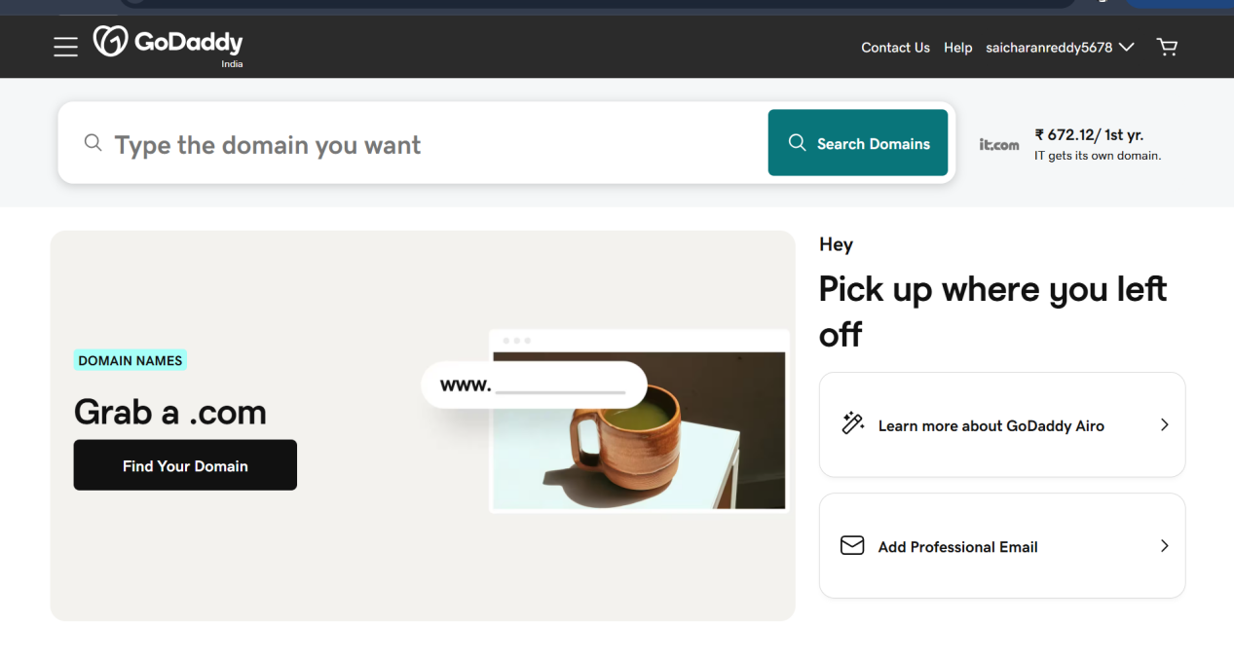

Purchased a domain from godaddy
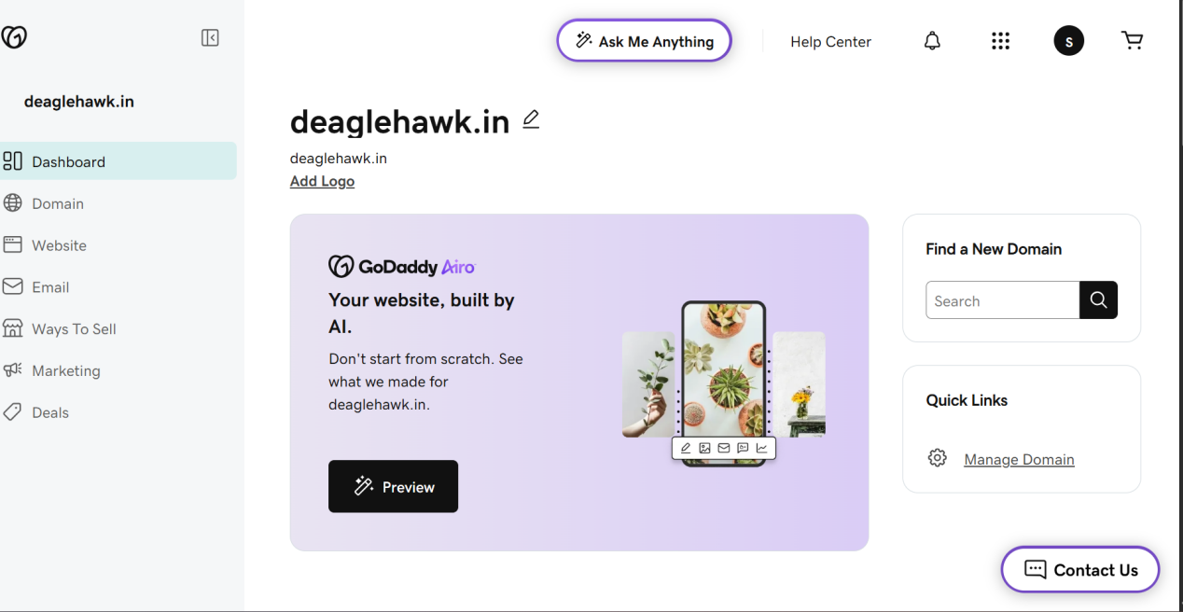

Deploy static website in S3

Here I need write an .html document from cli and error.html document

And I will bee uploading these documents to s3 website hosting

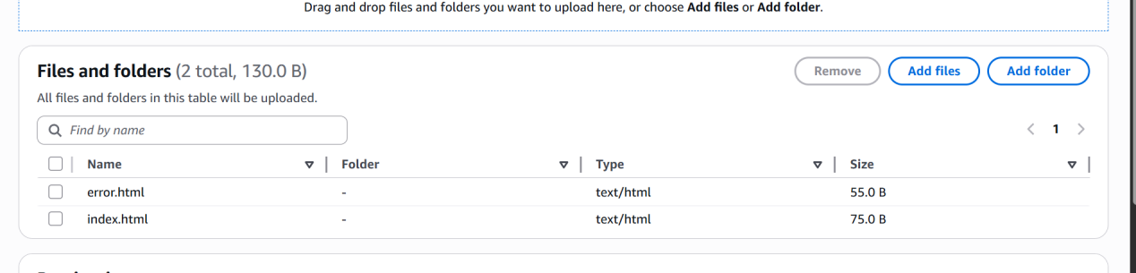

Then mention the .html files exactly the names in the static website hostic

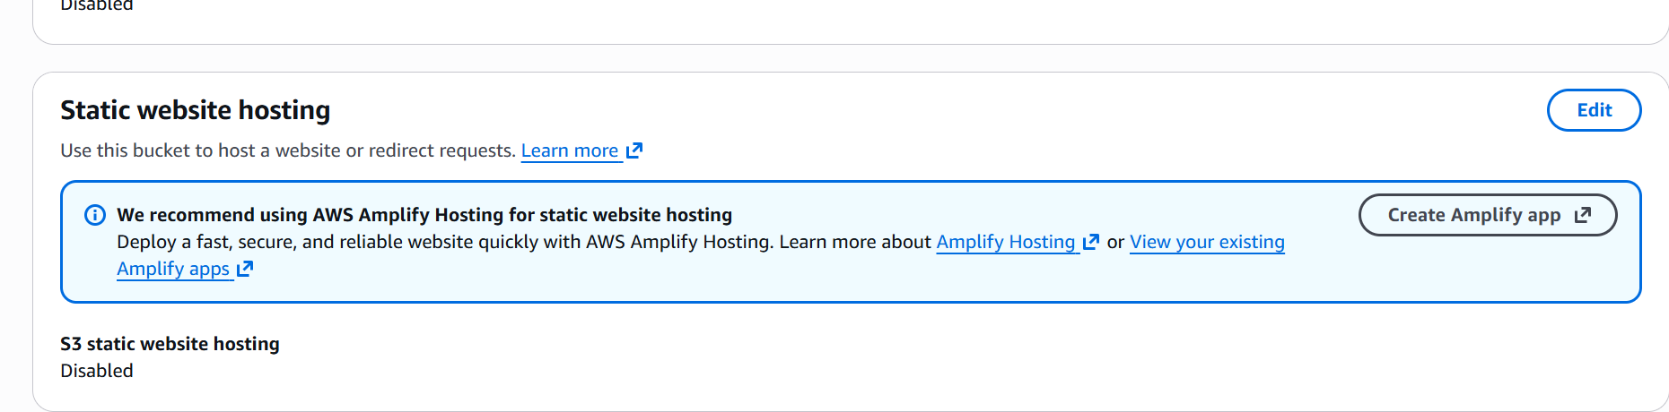

We need to give public with ACL for the .html files to deploy
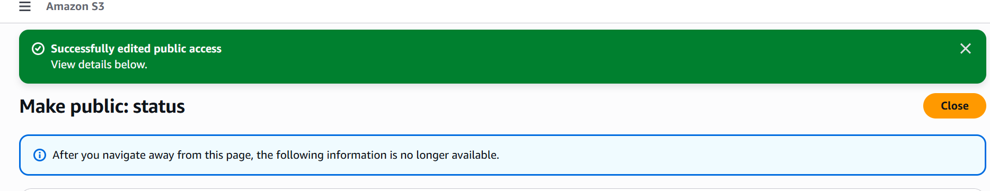

I have deployed a sample from the s3 bucket

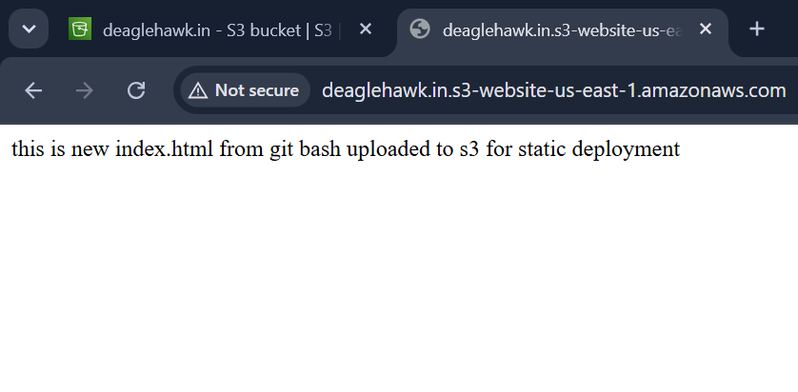
And without index.html file it automatically displays error.html content in browser

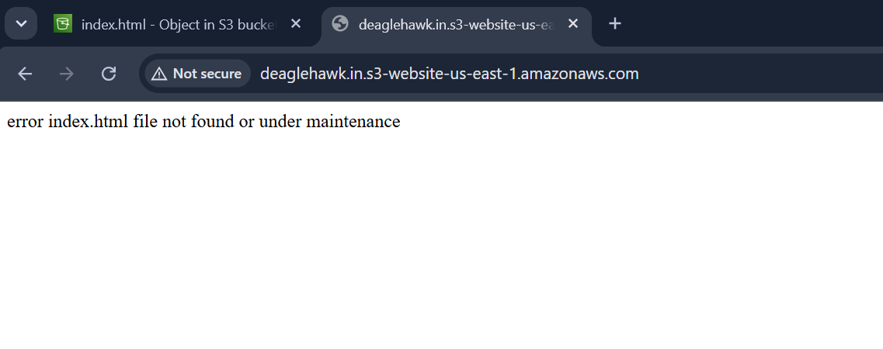

Create a CDN and attach one SSL certificate

CDN:- content delivery network

We should request a certificate for our domain name
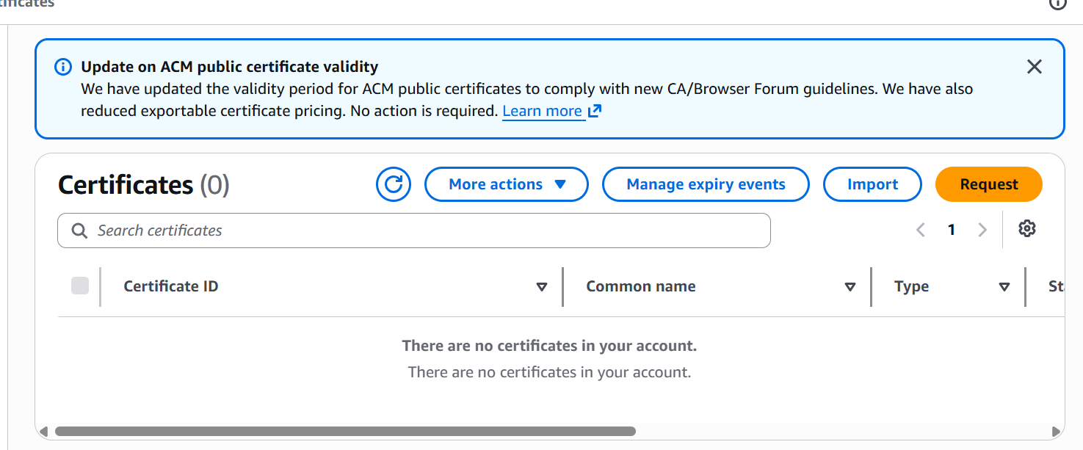

I have successfully requested a certificate for my domain name
The status will get approved once I have added CNAME

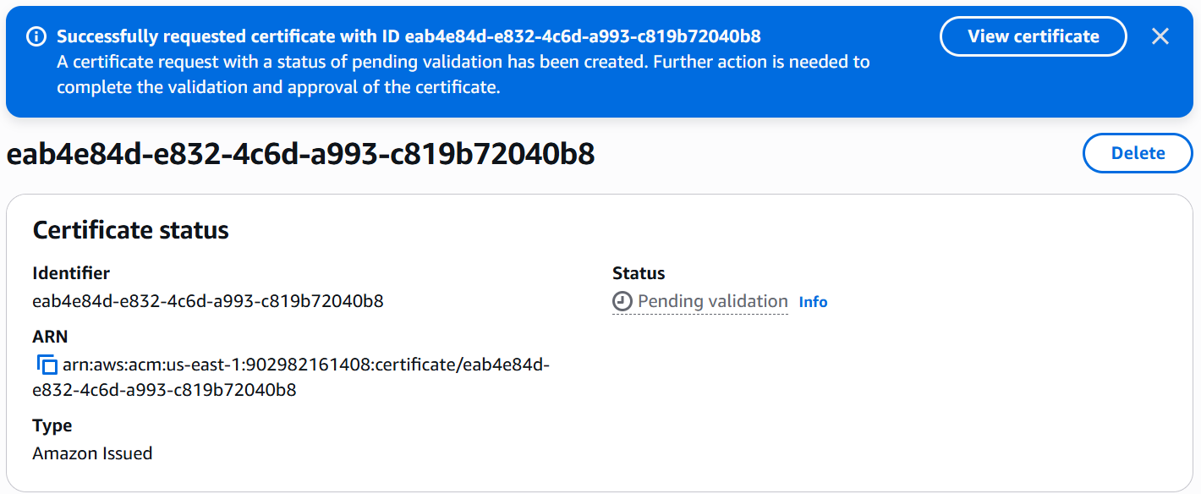

For approval I need to create a record in route 53 so that my status will get approved
For adding records we need to create hosted zones
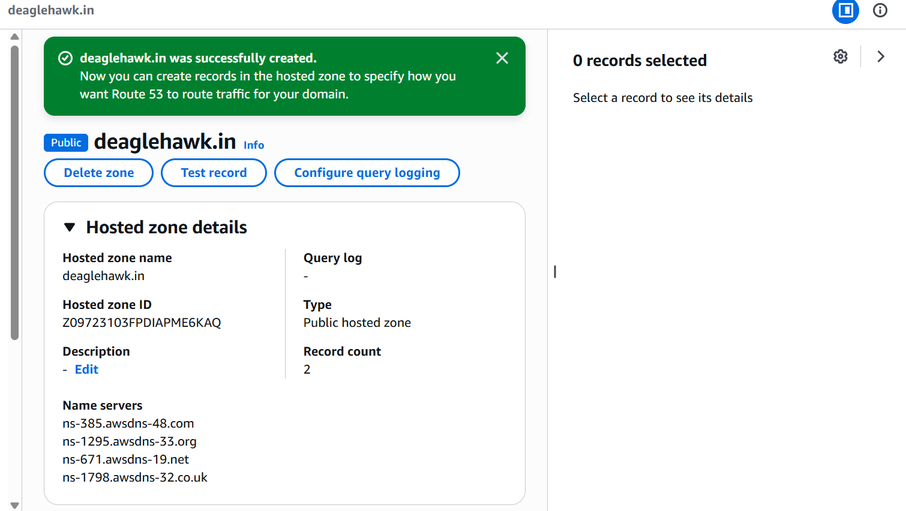

Now go to ACM 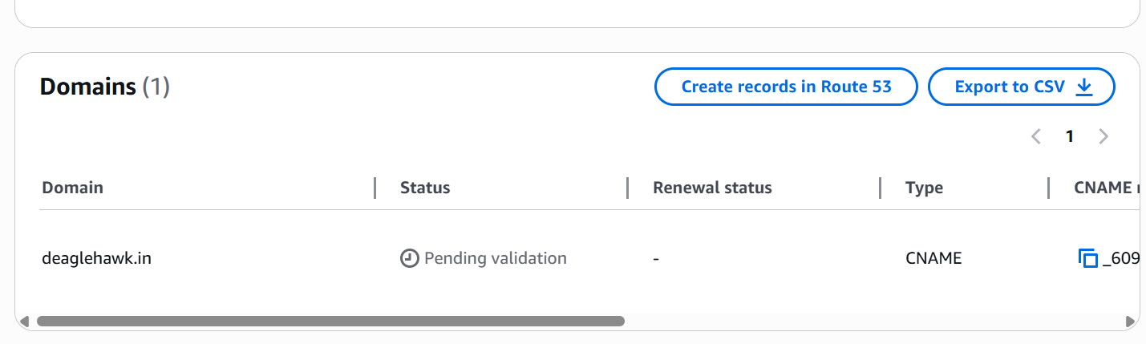
CLICK ON CREATE RECORDS IN ROUTE53

WE NEED CHANGE NAMESERVERS THAT PRESENT IN GODADDY WITH THE NAMESERVERS OF ROUTE53

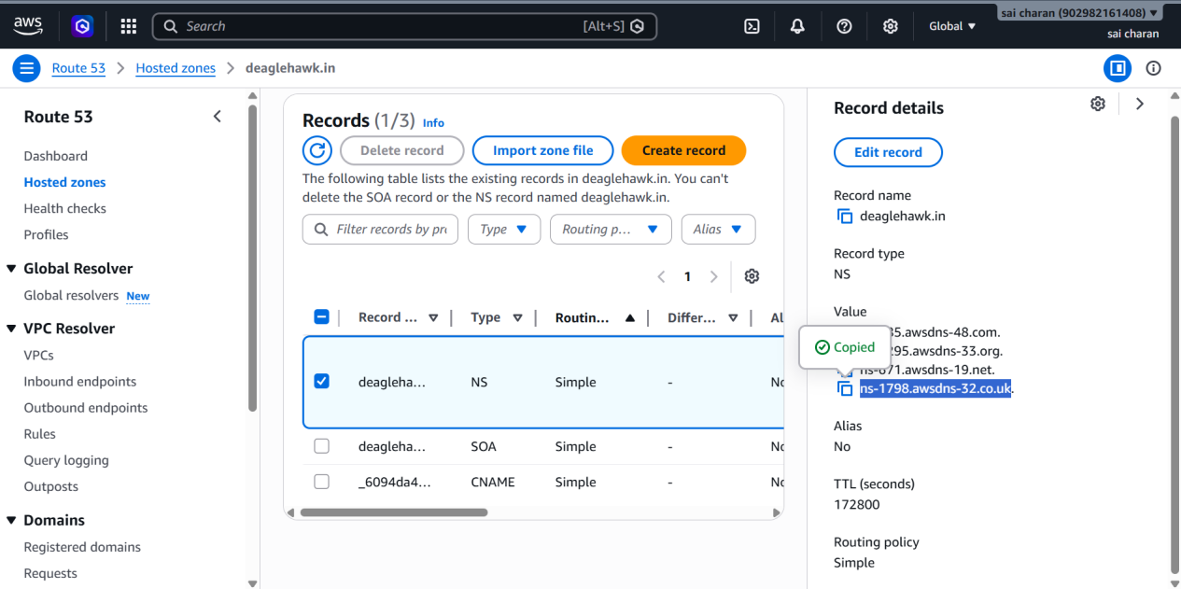
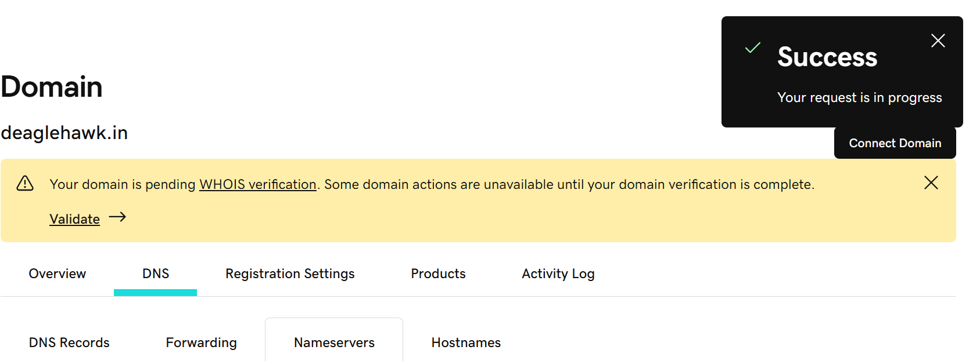

We can see successfully certificate was issued

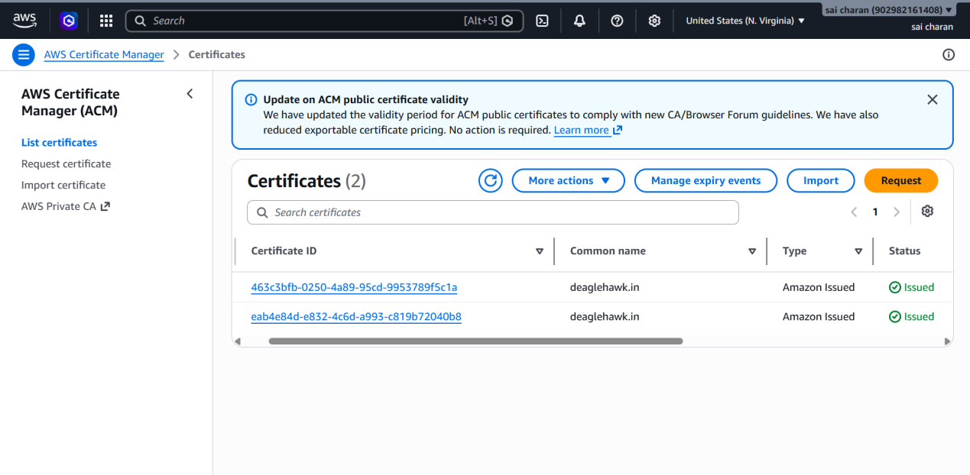
Here we are using cloudfront
And attaching an SSL certificate through ACM (amazon certificate manager)

Here by this we can decrease the latency of the website

And it is more secured

It can also be attached with route for the domain name of webserver

In CLOUDFRONT we should create a new distribution

Create a Route 53 hosted zone and map the domain with the CDN

Creating route53 hosted zone for CDN domain

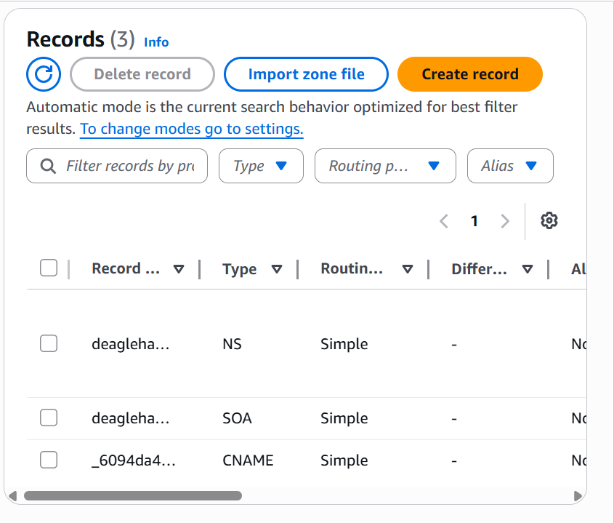
We can see the NS and SOA of the domain

CNAME was created from certificate creation in ACM

Changed origin path to s3 bucket

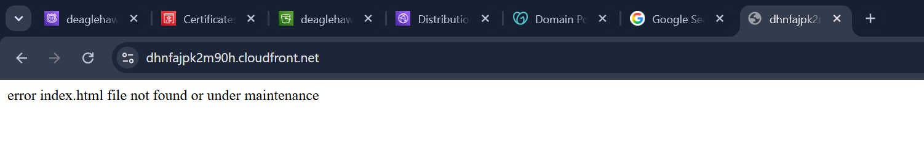
Configured domain name from route53
And whenever I logged in through domain

